

Foundations of Programming

Assignment No.: 14
PROBLEM STATEMENT: Write a C program to input a binary number from the user and convert it into a decimal number.

OBJECTIVE:

- To understand number system conversions.
- To learn how to convert binary numbers to decimal numbers in C.
- To practice the use of loops and arithmetic operations.
- To develop logical thinking for number system problems.

THEORY:
A binary number system uses only two digits: 0 and 1. Each digit of a binary number represents a power of 2 depending on its position. To convert a binary number into its decimal equivalent, each digit is multiplied by 2 raised to the power of its position and the results are added together. In C programming, this conversion can be implemented using loops and arithmetic operations.

ALGORITHM:
Step 1: Start
Step 2: Initialise variables:
- decimal = 0
- base = 1
Step 3: Read input binary number from user and store in n.
Step 4: Assign temp = n
Step 5: Repeat while n > 0:
- a. Compute digit = n % 10
- b. decimal = decimal + digit * base
- c. base = base * 2
- d. n = n / 10
Step 6: When n = 0, terminate loop.
Step 7: Display value of decimal.
Step 8: End

PLATFORM: Linux

INPUT: Binary number entered by the user.

OUTPUT: Displays the decimal equivalent of the given binary number.
SAMPLE INPUT:
Enter a binary number: 1011

SAMPLE OUTPUT:
Decimal equivalent = 11

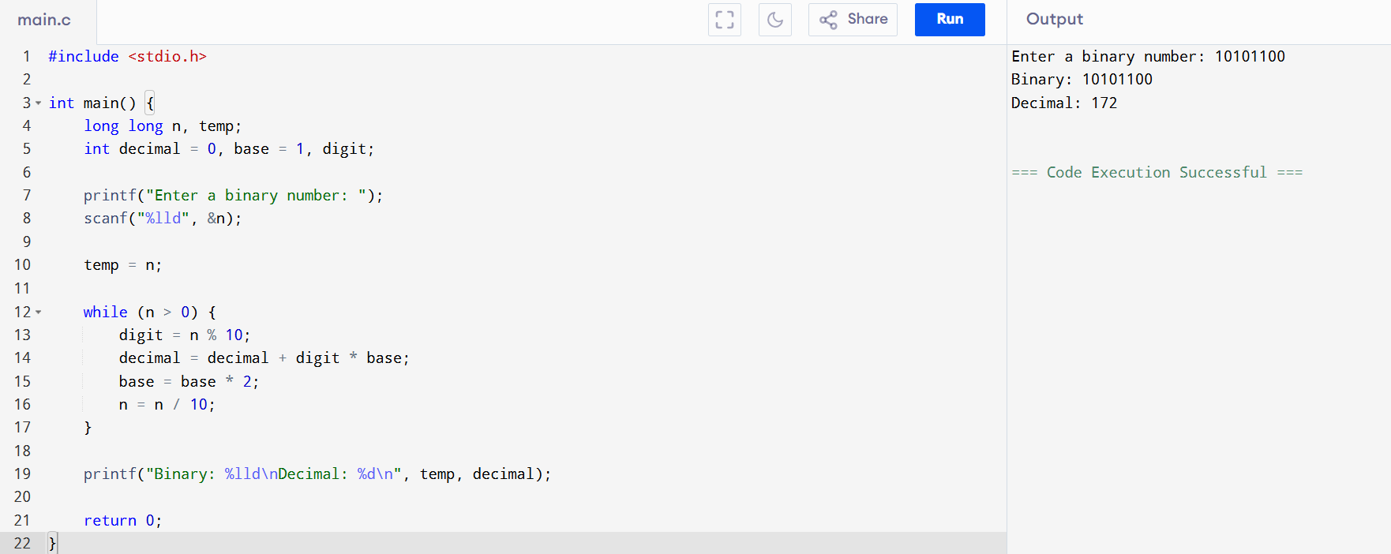
CONCLUSION: Thus, the C program successfully converts a binary number entered by the user into its decimal equivalent using loops and arithmetic operations.

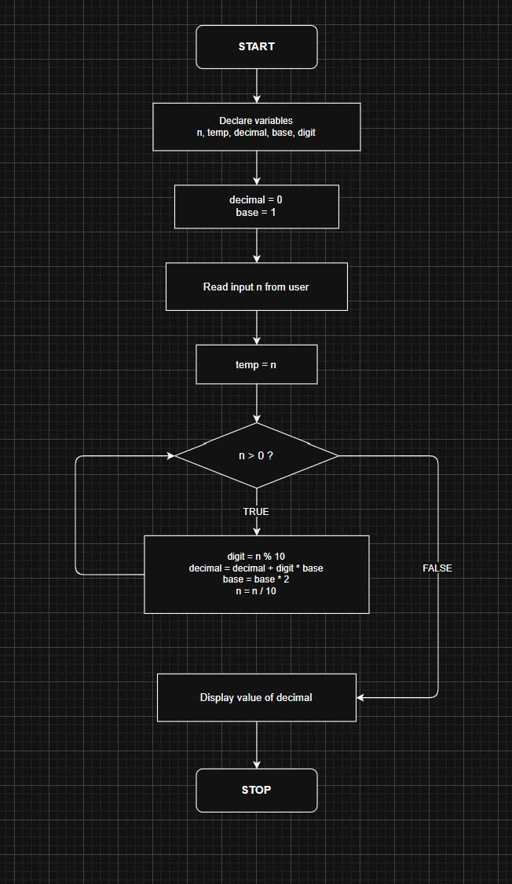
FLOWCHART:

